JAVA LAB PROGRAM

Submitted by,

Tamilvanan B.

2018503566.

MO Batch.

10-13-2020.

1. Write a Java program that checks the balance, credit limit and debit limit of the customer to withdraw the amount from his/her account.

If the availability of the balance is below 3000, the program should raise an low balance exception and prints a low balance message.

If the customer is crossing his credit or debit limit , the program should raise an limit exceeds exception and prints a limit exceeds message.

Program

import java.util.Scanner;

class MyException extends Exception{

String s1;

MyException(String s){

s1 = s;

}

public String toString(){

return s1;

}

}

public class Customer{

public static void main(String... args){

Scanner sc = new Scanner(System.in);

int acc[] = new int[100];

String name[] = new String[100];

int bal[] = new int[100];

int i = 0;

while(true){

System.out.print("1. Register\n2. Balance\n3. Credit amount\n4. Debit amount\n5.Exit\nEnter choice: ");

int n = sc.nextInt();

if(n == 1){

System.out.print("Enter name: ");

name[i] = sc.next();

System.out.print("Enter Account number: ");

acc[i] = sc.nextInt();

System.out.print("Enter initial amount: ");

bal[i] = sc.nextInt();

i++;

}

else if(n == 2){

System.out.print("Enter Account Number: ");

int num = sc.nextInt();

int j = 0;

while(true){

if(acc[j] == num){

if(bal[j] < 3000){

try{

MyException obj = new MyException("Low Balance");

throw obj;

}

catch(Exception e){

System.out.print(e);

}

break ;

}

else{

System.out.print("Balance: " + bal[j]);

break ;

}

}

else{

j++;

}

}

System.out.print("\n");

}

else if(n == 3){

System.out.print("Enter Account Number: ");

int num = sc.nextInt();

int j = 0;

while(true){

if(acc[j] == num){

System.out.print("Enter amount: ");

int amt = sc.nextInt();

if(amt > 5000){

try{

MyException obj = new MyException("Credit amount exceeded");

throw obj;

}

catch(Exception e){

System.out.print(e);

}

break ;

}

else{

bal[j] += amt;

break ;

}

}

else{

j++;

}

}

System.out.print("\n");

}

else if(n == 4){

System.out.print("Enter Account Number: ");

int num = sc.nextInt();

int j = 0;

while(true){

if(acc[j] == num){

System.out.print("Enter amount: ");

int amt = sc.nextInt();

if(amt > 1000){

try{

MyException obj = new MyException("Debit amount exceeded");

throw obj;

}

catch(Exception e){

System.out.print(e);

}

break ;

}

else{

bal[j] -= amt;

break;

}

}

else{

j++;

}

}

System.out.print("\n");

}

else if(n == 5){

break;

}

}

}

}

Output

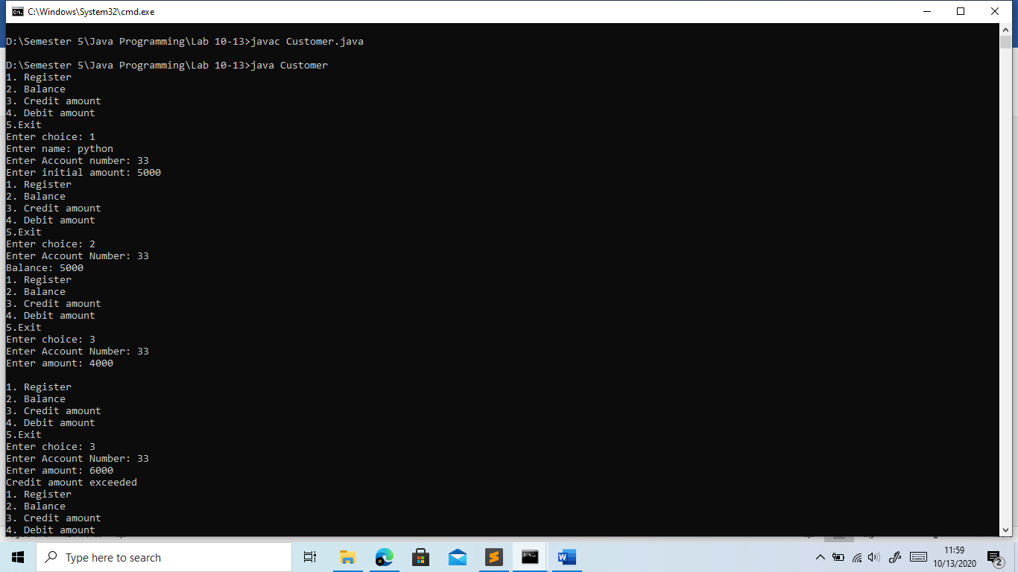

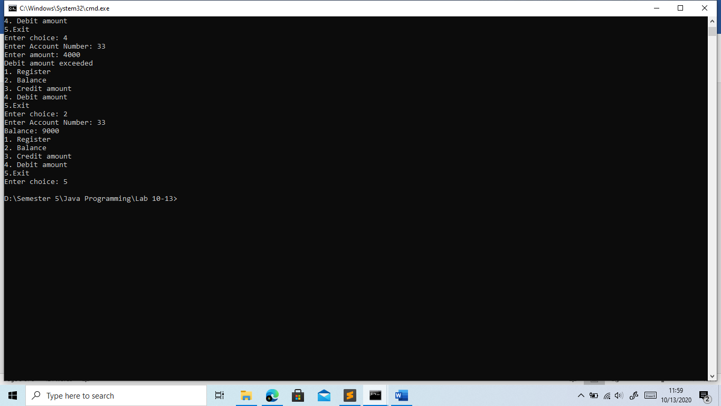

2. For a library application, write a java program that raises an exception whenever the lapsed renewal day and fine amount exceeds a limit.

Program

import java.util.Scanner;

class Exc extends Exception{

String s1;

Exc (String s){

s1 = s;

}

public String toString(){

return s1;

}

}

public class Library{

public static void main(String... args){

Scanner sc = new Scanner(System.in);

while(true){

System.out.print("1. Renewal\n2. Fine Amount\n3. Exit\nEnter choice: ");

int n = sc.nextInt();

if(n == 1){

System.out.print("Enter the current date: ");

int date = sc.nextInt();

if((14 - date) < 0){

try{

Exc obj = new Exc("Renewal date Exceeded");

throw obj;

}

catch(Exception e){

System.out.print(e);

}

System.out.print("\n");

}

else{

System.out.print("You\'ve " + String.valueOf(14 - date) + " days left.");

System.out.print("\n");

}

}

else if(n == 2){

System.out.print("Enter the current date: ");

int date = sc.nextInt();

if((14 - date) < 0){

int fine = (date - 14) \* 4;

if (fine > 10){

try{

Exc obj = new Exc("Fine amount Exceeded");

throw obj;

}

catch(Exception e){

System.out.print(e);

}

System.out.print("\n");

}

}

else{

System.out.print("You\'ve " + String.valueOf((14 - date)\*4) + " fine amount to be paid.");

System.out.print("\n");

}

}

else if(n == 3){

break;

}

}

}

}

Output

